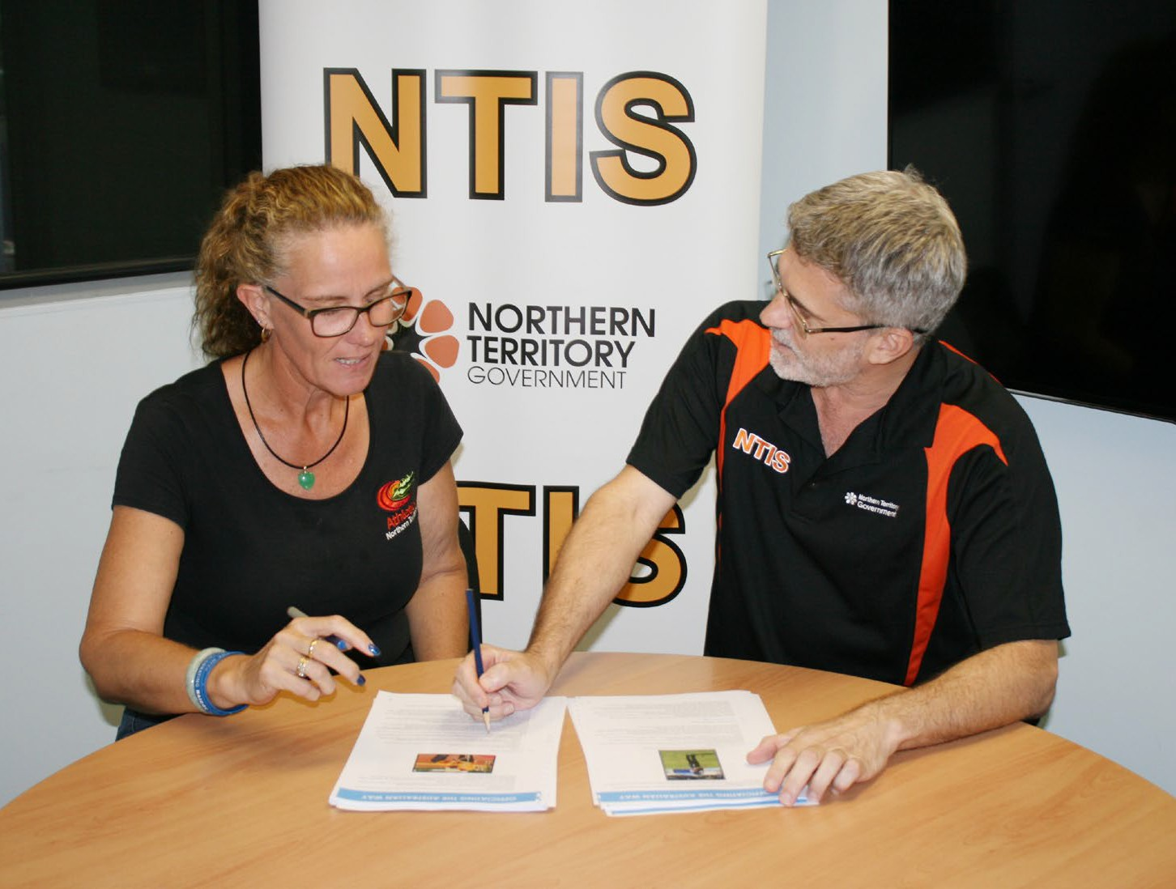

Northern Territory High Performance Officiating Program
The Mentoring Program

www.nt.gov.au

The Mentoring Program
The High Performance Officiating Program (HPOP) relies upon a formal mentoring relationship agreement that is mutually beneficial for each HPOP official and mentor. The HPOP official will be required to work with a mentor for the duration of the program.
The mentor will be responsible, in consultation with the selected official, specialist service providers and PSB, for assisting and providing regular feedback to the HPOP official throughout the agreement period. This will include:
- Identifying and recommending, to the HPOP official and PSB, professional development opportunities for the official;
- Informing the NTIS and PSB of the HPOP officials’ progress;
- Attending Induction and Final Workshops;
- Involvement in the mentor training sessions – delivered face to face and online;
- Attending professional development opportunities, as required, with the HPOP official.

Benefits to the Mentor
A mentor’s life, on a personal and professional level, can be enriched through the following experiences (www.mindtools.com):

Building leadership skills
Mentoring helps develop the ability to motivate and encourage others. This can help the mentor become a better manager, employee, and team member.

Improved communication skills
Because the mentee can come from a different background or environment, the mentor and mentee may not “speak the same language.” This encourages finding a way to communicate more effectively in order to successfully navigate through the mentoring relationship.

Learn new perspectives
By working with someone less experienced and from a different background, the mentor can gain a fresh perspective on things and learn a new way of thinking – which can help in both work and personal lives.

Career advancement
Refining leadership skills can strengthen on-the-job performance, helping enhance promotion prospects. Demonstrating an ability to help others learn and grow is becoming more and more essential to advancement in today’s business world.

Personal satisfaction
It can be very personally fulfilling to know one has directly contributed to someone else’s growth and development. Seeing a mentee succeed as result of one’s input is often a reward in itself.
The Durham University 2009 mentor survey found that mentors stated that the greatest benefit they derived from the process was providing them with an opportunity to reflect on their own practice and develop a network of enabling relationships.

How much time is involved?
This is decided between the HPOP official and the mentor when an agreement is formulated. There will be two compulsory weekend workshops held over the second weekend of February and November together with a number of sessions for the officials which the mentor is also encouraged to attend.

What training is involved?
The NTIS will provide E-Learning training for the mentor prior to the first workshop in February plus additional face to face training at the first workshop. This training is provided free and will be conducted by one of Australia’s best trainers in mentoring for sport.

Who can be a mentor?
Almost anyone can become a mentor to help another person maximize their potential, but there are definitely characteristics and skills that stand out for successful mentors. These include:
- Providing honest, constructive criticism;
- Being trustworthy and able to keep discussions confidential;
- Having good listening skills and listening in order to understand, not reply;
- The ability to teach, not just tell, such as asking questions to help others determine the answers for themselves;
- Being well respected in their employment/business/profession and having the experience necessary to be able to discuss a wide range of topics and situations;
- Having the time available to help others;
- Having a positive, upbeat and caring attitude;
- Having the ability to motivate the mentee;
- Having a good sense of humour with the ability to take situations seriously but be able to laugh at themselves; and
- Being open to two-way learning, not only helping the mentee learn but also realizing there are things they could learn from the mentee.

