**Arts and Culture COVID-19 Interruption Support provided urgent support to Northern Territory artists and arts workers, sole traders and organisations that have been directly impacted by the COVID-19   
Chief Health Officer directed restrictions and lockdowns.**

Eligible individuals, groups and organisations who experience a loss of income due to activities that were cancelled because of the lockdown were encouraged to apply. Applicants ineligible for the [Territory Business Lockdown Payment](https://businessrecovery.nt.gov.au/businesses/territory-business-lockdown-payment-program) and earn less than $75,000 per annum were eligible to apply.

# To date, $75,654 has been awarded through the Arts and Culture COVID-19 Interruption Support category across two rounds providing 99 reimbursements for artists and arts workers experiencing a loss of income due to the lockdown measures.

# $75,654 awarded

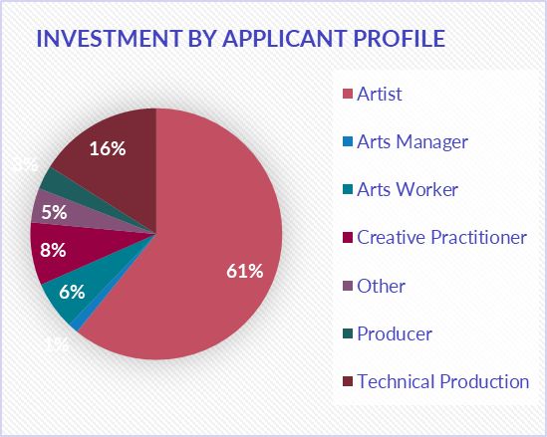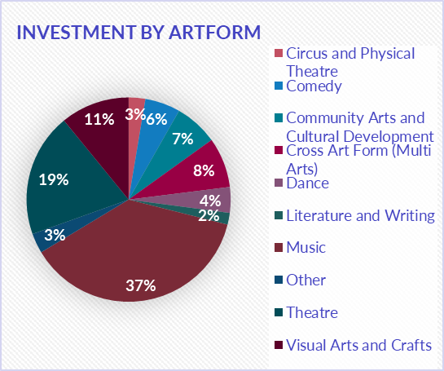

* 165 applications were received and 99 awarded funding (60 per cent success).
* 66 applications were ineligible, withdrew or were unable to demonstrate a loss of income.

Key outcomes

* The highest percentage of support was dedicated to Artists (61 per cent), followed by Technical Production (16 per cent).
* The challenges identified for artists to demonstrate a loss of income includes:
* artists and art workers could not show evidence of a loss of income due to the informal way in which artists are often engaged to work; and
* bookings and/or cancellations were made via text message or phone call with no written confirmation of payment amounts or contract.
* Organisations earning over $75,000 were referred to the Territory Business Lockdown Payment Program.

List of Successful applicants

|  |  |  |  |  |  |
| --- | --- | --- | --- | --- | --- |
| FIRST NAME | LAST NAME | Region | ART FORM | APPLICANT'S PROFILE /ROLE | AMOUNT APPROVED |
| Danielle | Aquilina | Greater Darwin | Music | Artist | $500 |
| Donna | Jackson | Greater Darwin | Community Arts and Cultural Development | Other | $1000 |
| Nicholas | Parry | Greater Darwin | Community Arts and Cultural Development | Artist | $1000 |
| Amanda | Harris | Central Australia | Dance | Arts Worker | $770 |
| Denique | Stewart | Greater Darwin | Community Arts and Cultural Development | Arts Worker | $88 |
| Betty | Sweetlove | Central Australia | Other | Artist | $400 |
| Dave | Crow | Central Australia | Music | Artist | $350 |
| Sarah | Reuben | Greater Darwin | Theatre | Artist | $1504.60 |
| Joshua | Grant | Greater Darwin | Music | Technical Production | $990 |
| Iona | Francis | Greater Darwin | Theatre | Technical Production | $1293.62 |
| Lukas | Bendel | Greater Darwin | Music | Artist | $1000 |
| Judith | Durnford | Greater Darwin | Visual Arts and Crafts | Artist | $1000 |
| Martina | Capurso | Central Australia | Visual Arts and Crafts | Creative Practitioner | $1000 |
| Robert | Hoad | Greater Darwin | Music | Artist | $1000 |
| James | Mangohig | Greater Darwin | Literature and Writing | Creative Practitioner | $700 |
| Jeremy | Conlon | Central Australia | Other | Technical Production | $990 |
| Gabriel | Curtin | Central Australia | Literature and Writing | Artist | $100 |
| Linda | Masters | Greater Darwin | Music | Artist | $1000 |
| Raymond | Masters | Greater Darwin | Music | Artist | $700 |
| Kelly | Hickey | Central Australia | Literature and Writing | Artist | $100 |
| Bryn | Wackett | Greater Darwin | Dance | Creative Practitioner | $558.60 |
| Felicity | Hayes | Central Australia | Literature and Writing | Artist | $200 |
| Daniel | Davies | Greater Darwin | Music | Artist | $750 |
| Bryan | West | Greater Darwin | Theatre | Technical Production | $1870 |
| Jack | Tinapple | Greater Darwin | Music | Artist | $800 |
| FIRST NAME | **LAST NAME** | **Region** | **ART FORM** | **APPLICANT'S PROFILE /ROLE** | **AMOUNT APPROVED** |
| Michele | Masino | Greater Darwin | Music | Artist | $330 |
| Maureen | O’Keefe | Central Australia | Literature and Writing | Creative Practitioner | $300 |
| Glenn | Morrison | Central Australia | Music | Artist | $900 |
| Adam | Scriven | Greater Darwin | Music | Artist | $500 |
| James | Pile | Greater Darwin | Music | Artist | $1000 |
| Danielle Sheree Lorraine | Aquilina | Greater Darwin | Comedy | Creative practitioner | 1,000.00 |
| Haneen | Martin | Greater Darwin | Community Arts and Cultural Dev | Producer | 1,000.00 |
| Danielle | McMurrich | Greater Darwin | Cross Art Form (Multi Arts) | Arts worker | 1,000.00 |
| Benjamin | Collins-Graham | Greater Darwin | Music | Technical production | 1,000.00 |
| Paul | Pyne | Greater Darwin | Music | Artist | 1,000.00 |
| Owen | Paroz | Greater Darwin | Music | Artist | 1,000.00 |
| Aden | Mackay | Greater Darwin | Music | Artist | 950.00 |
| Addison | Young | Greater Darwin | Music | Artist | 400.00 |
| Amanda | Harris | Central Desert | Music | Artist | 680.00 |
| Hemlock | Mejarne | Greater Darwin | Circus and Physical Theatre | Artist | 1,000.00 |
| Danica | Jenner | Greater Darwin | Comedy | Artist | 660.00 |
| Madeleine | Brown | Greater Darwin | Dance | Artist | 300.00 |
| Brenton | Ryan | Greater Darwin | Cross Art Form (Multi Arts) | Technical production | 1,000.00 |
| Brent | Watkinson | Greater Darwin | Comedy | Artist | 418.00 |
| Angelique | Datseres | Greater Darwin | Music | Artist | 600.00 |
| Isabella | Vicente | Greater Darwin | Music | Artist | 850.00 |
| Linda | Masters | Greater Darwin | Music | Artist | 1,000.00 |
| Leah | Potter | Greater Darwin | Comedy | Artist | 450.00 |
| Iona | Francis | Greater Darwin | Theatre | Technical production | 1,000.00 |
| Sandra | Thibodeaux | Greater Darwin | Theatre | Artist | 914.00 |
| Danielle | Andrews | Greater Darwin | Dance | Artist | 890.00 |
| Nicholas | Yates | Greater Darwin | Music | Artist | 1,000.00 |
| Kerry | Sandhu | Greater Darwin | Visual Arts and Crafts | Artist | 602.00 |
| Dillon | Parker | Greater Darwin | Music | Artist | 1,000.00 |
| Sarah | Reuben | Greater Darwin | Theatre | Artist | 750.00 |
| FIRST NAME | **LAST NAME** | **Region** | **ART FORM** | **APPLICANT'S PROFILE /ROLE** | **AMOUNT APPROVED** |
| Scott | Gooding | Greater Darwin | Theatre | Creative practitioner | 1,000.00 |
| Tristan | Etherington | Greater Darwin | Music | Artist | 1,000.00 |
| Jocelyn | Tribe | Greater Darwin | Visual Arts and Crafts | Creative practitioner | 1,000.00 |
| Kevin | Stack | Greater Darwin | Music | Artist | 225.00 |
| Laura-Jan | Devlin | Central Desert | Music | Arts worker | 520.00 |
| Dakota | Smith | Greater Darwin | Music | Artist | 700.00 |
| Kostantine | Hatzivalsamis | Greater Darwin | Comedy | Arts worker | 250.00 |
| Finn | Williams | Greater Darwin | Theatre | Technical production | 1,000.00 |
| Scott | Murphy | Greater Darwin | Music | Artist | 1,000.00 |
| Denique | Stewart | Greater Darwin | Community Arts and Cultural Dev | Arts Worker | 1,000.00 |
| Elshiela | Ibo | Greater Darwin | Theatre | Artist | 580.00 |
| Christine | Ng | Alice Springs | Music | Other | 650.00 |
| James | Pile | Greater Darwin | Music | Artist | 900.00 |
| Michelle (Miki) | Ensbey | Greater Darwin | Cross Art Form (Multi Arts) | Technical production | 1,000.00 |
| Cassidy | Gerken | Greater Darwin | Music | Other | 700.00 |
| Bryn | Wackett | Greater Darwin | Dance | Creative practitioner | 560.00 |
| Phoebe Olivia | Wear | Greater Darwin | Music | Artist | 400.00 |
| Robert | Hoad | Greater Darwin | Theatre | Artist | 1,000.00 |
| Tynan | Corless | Greater Darwin | Comedy | Artist | 697.00 |
| Bryan | West | Greater Darwin | Theatre | Technical production | 965.00 |
| Tarzan | McDonald | Greater Darwin | Visual Arts and Crafts | Artist | 1,000.00 |
| Eve | Lynch | Greater Darwin | Comedy | Artist | 502.00 |
| Sean Robert | Guy | Greater Darwin | Comedy | Artist | 250.00 |
| Kyle | Walmsley | Greater Darwin | Theatre | Artist | 544.00 |
| Jacqueline | Perrin | Greater Darwin | Visual Arts and Crafts | Artist | 1,000.00 |
| Kadek | Hobman | Greater Darwin | Music | Artist | 700.00 |
| Jing | Jin | Greater Darwin | Cross Art Form (Multi Arts) | Artist | 1,000.00 |
| Ioanna | Thymianidis | Greater Darwin | Other | Artist | 1,000.00 |
| FIRST NAME | **LAST NAME** | **Region** | **ART FORM** | **APPLICANT'S PROFILE /ROLE** | **AMOUNT APPROVED** |
| Philamena | McKenzie-Young | Greater Darwin | Music | Arts worker | 900.00 |
| Kat | Byron | Greater Darwin | Music | Artist | 565.00 |
| Samantha | Tran | Greater Darwin | Circus and Physical Theatre | Producer | 1,000.00 |
| Mark | Holman | Greater Darwin | Cross Art Form (Multi Arts) | Technical production | 1,000.00 |
| Thomas | Midena | Greater Darwin | Theatre | Artist | 606.00 |
| Bronte | Zerafa | Greater Darwin | Theatre | Producer | 325.00 |
| Hanada | Ghazala | Greater Darwin | Theatre | Artist | 1,000.00 |
| Nicole | Zicchino | Greater Darwin | Theatre | Arts worker | 189.35 |
| Daniel | Heilbronn | Greater Darwin | Visual Arts and Crafts | Artist | 657.00 |
| Jack | MacMillan | Greater Darwin | Theatre | Artist | 250.00 |
| Hannah | Illingworth | Greater Darwin | Community Arts and Cultural Dev | Arts manager | 1,000.00 |
| Peta | Goodrem | Greater Darwin | Visual Arts and Crafts | Artist | 1,000.00 |
| Jesse | Ocean | Greater Darwin | Visual Arts and Crafts | Artist | 1,000.00 |
| Michele | Masters | Greater Darwin | Music | Artist | 762.00 |
| Jimmy | Bamble | Greater Darwin | Community Arts and Cultural Dev | Artist | $97.50 |
| June | Mills | Greater Darwin | Cross Art Form (Multi Arts) | Other | 1,000.00 |