Review of the Northern Territory Domestic, Family and Sexual Violence Reduction Framework’s Action Plan 1: Changing attitudes, intervening earlier and responding better 2018-2021
Summary report

Review of the Northern Territory domestic, and sexual violence reduction framework action plan 1 summary report
Overview
Domestic, family and sexual violence (DFSV) is a major social issue in the Northern Territory.
The Northern Territory’s Domestic, Family and Sexual Violence Reduction Framework 2018-2028: Safe, respected and free from violence (the Framework) outlines a 10 year approach to reducing all forms of DFSV. The Framework acknowledges that preventing DFSV requires long-term strategies that support generational change and it articulates a shared vision and commitment for a future where women and children are safe and families are supported.
Action Plan 1: Changing attitudes, intervening earlier and responding better 2018-2021 (Action Plan 1) was the first action plan under the Framework. Action Plan 1 set an ambitious and important first program of work under the Framework, through 78 actions across the five Framework outcomes.
As the lead agency for the Framework, the Department of Territory Families, Housing and Communities (TFHC) was allocated $6.49 million per annum to implement Action Plan 1 from 2019-20 onwards.
In 2023, TFHC completed a review of Action Plan 1. This summary report presents the review findings into the implementation and governance of Action Plan 1 and recommendations for the Framework’s second action plan. The summary report is available on the TFHC Domestic, family and sexual violence reduction website.
“DFSV is a major social issue that can only be addressed through generational change, and is the subject of a number of long-term strategies and frameworks across Australia.”
(Review commentary)
“The nature and extent of DFSV in the Northern Territory is distressing. People of all ages and circumstances are affected. Too many women and children’s lives are defined by violence and abuse perpetrated against them by close family and or intimate partner”
(adapted from Framework Foreword)

Framework outcomes
The Framework outlined five outcome areas:
- Domestic, family and sexual violence is prevented and not tolerated.
- Territorians at risk of experiencing violence are identified early and provided with effective interventions.
- People experiencing domestic, family and sexual violence are protected and helped to recover and thrive.
- Perpetrators are held accountable and connected early to responses that change their behaviours and reduce violence.
- Legislation, policy and funding models enable a responsive, high quality and accountable domestic, family and sexual violence service system.

Responsibilities
Preventing DFSV requires a collaborative approach from the Northern Territory Government and non-government sector.
To advise on implementation of the Framework, a DFSV Cross Agency Working Group (CAWG) was established in 2019, which includes membership from:

- Department of Territory Families, Housing and Communities
- Department of Education
- Northern Territory Health
- Department of the Attorney-General and Justice
- Northern Territory Police
- Department of Chief Minister and Cabinet
- Specialist DFSV network representatives
- Sector peak bodies
The CAWG is an advisory and information sharing group on all policy, service and program development plans and activities that work towards the Framework’s outcomes.
“Achieving long term social and cultural change requires concerted and sustained effort through shared responsibility and partnership”
(adapted from Framework Foreword)

Review approach
The review into Action Plan 1:
- presented a summary of progress for each action;
- examined the extent to which early progress against the Framework’s outcomes is seen; and
- provided insights and recommendations for the design, implementation, governance and monitoring of Action Plan 2.
The review drew on Northern Territory and national data, documents produced over the life of Action Plan 1, and survey and interview data from stakeholders.

Review findings
Final status of the 78 actions
Action Plan 1 contained a diverse set of actions, reflecting existing operational activity as well as initiatives of significant strategic priority for government and/or the non-government sector. Action Plan 1 established a wide ranging and ambitious agenda for implementation - one that required effective agency, cross agency, and cross sector collaboration to achieve.
The Final Status Report for Action Plan 1 is published online. A summary of action status (Figure 1) illustrates that 86% (67 actions) were assessed as either fully completed, established as on-going activity of government, or confirmed as a near-finalised products, soon to be released.
The remaining 11 actions had limited activity (10%) or did not progress (4%). These actions were often scoped too broadly or too prescriptively with unattainable expectations; or were intentionally reprioritised due to resource limitations or delays due to COVID-19 disruptions.
Figure 1: Final status of the 78 actions under Action Plan 1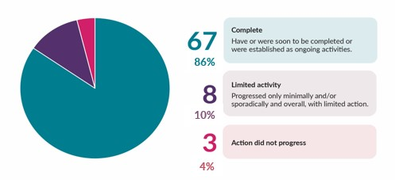
Strengths
- Action Plan 1 had a diverse range of actions and outputs including, policies, legislative amendments, grant schemes and training resources.
- Actions were in large part clearly articulated, appropriate for a reform agenda, and were implemented as intended.
- The extended timeframe from 2018-2021 to 2019-2023 allowed for the progression of actions to completion, or their establishment as ongoing business. The extended timeframe also allowed for the review to inform planning of Action Plan 2, with some key learnings implemented immediately.
- Stakeholders reported that following Action Plan 1 there is a stronger shared understanding of the needs of victim survivors across government and in the community and that efforts to challenge attitudes and behaviours that drive DFSV have been advanced.
- Largely, stakeholders were satisfied with the governance of Action Plan 1.
Action Plan 1 output highlights
- NT Sexual Violence Prevention and Response Framework
- NT Gender Equality Statement of Commitment and Gender Equality Action Plan 2022-25
- Safe, Respected and Free from Violence Prevention Grants program
- NT Domestic and Family Violence Risk Assessment and Management Framework (RAMF)
- NT Social and Emotional Learning Package (Department of Education)
- NT Health DFSV Reduction Strategic Plan 2018-2021
- Specialist Approach to Domestic Violence at the Alice Springs Local Court
- Family Safety Framework (FSF)
- NT DFSV Workforce and Sector Development Plan
- Men’s behaviour change programs
- Safe and Together approach
- Legislative amendments
- Enhanced Specialist Services Grants
Through these activities, members of the CAWG reported improvements for victim survivors, enhanced agency and sector collaboration, and the expansion of prevention-oriented activity.

Challenges
- The timeframe for the development of Action Plan 1 was compressed and required the bringing together of a diverse mix of initiatives (existing and planned) from participating agencies.
- Documentation on the process for the development of Action Plan 1 was limited and its production lacked a strong centralised quality assurance and coordination process.
- Some actions proved difficult to implement and report on. This was particularly the case for actions that were: expressed in broad, vague, or unclear terminology; peripheral to the central agenda of the Framework; had uncertain origins, unclear rationale or poor strategic alignment; or which reflected day-to-day agency business, rather than a distinct reform initiative.
- Implementation, progress monitoring and reporting was made more challenging due to the absence of project plans for each action and a comprehensive monitoring and evaluation plan for the Framework.
- Over the course of Action Plan 1, two public progress updates were released to increase transparency and public accountability on the plan’s progress. However, agencies self-rated the status of their actions with limited direction and definition, which resulted in questions surrounding the reliability of reports.
- Despite the extension, the timeframe for Action Plan 1 was insufficient to see significant progress toward the Framework’s four high level indicators of success:
  - a reduction in the prevalence of domestic violence and sexual assault
  - an increase in the proportion of women who feel safe in their communities
  - a reduction in deaths related to domestic violence and sexual assault
  - a reduction in the proportion of children exposed to their mother’s or carer’s experience of domestic violence.
- This finding is consistent with the understanding that long-term, sustained, and collaborative efforts are required to reduce, and ultimately eliminate, DFSV. Change of this nature is generational and requires ongoing commitment, investment, and monitoring.
“Enhanced accountability measures [are needed] to better support the development of initiatives under Action Plan 2, and the monitoring and evaluation of work taken to progress Action Plan 2.”
– CAWG member
“Clearer actions [are needed] that CAWG can realistically deliver on, and which have clear accountability allowing for detailed and accurate progress reporting.”
– CAWG member

Opportunities and learnings
- The development of actions requires a coordinated, central quality assured approach, with a built-in focus on monitoring, evaluation and reporting. The review presented recommendations for the development of Action Plan 2 including:
  - ensuring actions are clearly worded, relevant, and have a project plan for implementation and SMART indicators for reporting
  - improving structural arrangements, accountability mechanisms, and validation processes for the reporting of actions
  - incorporating the views and experiences from service users and victim survivors into the detailed design and evaluation of actions.
- The importance of reliable reporting cannot be overstated and the review presented recommendations for the reporting of Action Plan 2 including:
  - improving transparency and accountability through a progress reporting framework, which includes definitions, timelines, templates and protocols for progress reports
  - bolstering the reporting abilities of both government and funded service providers to enable timely and rigorous assessments of key measures and the building of a service provision evidence base
  - dedicating resources to a data improvement project for the Framework and its associated plans.
- How success is defined and measured requires careful consideration. Indicators which demonstrate that victim survivors are more supported, rather than reduced rates of violence, may be more relevant indicators in the short and medium term. For example, it is more likely that the reporting of DFSV and demand for services will increase in the medium term because of increased awareness and improved responses. This increase in reporting may not reflect an increase in violence, but rather a correcting of existing underreporting.
“Prevalence of violence against women will remain static in the short and medium term, but will begin to decrease with improvements in gender equality and reductions in the drivers of violence.”
– OurWatch Counting on Change

“The [Action Plan 2] initiatives are exceptionally well framed, but to see real and meaningful actions that save lives, we need to co-design the detail. When reform projects are co-designed, people start working together like never before.”
– CAWG member
- While stakeholders were largely satisfied with the governance of Action Plan 1, the review recommended several improvements to arrangements to support Action Plan 2, such as:
  - reflecting the collaborative nature of CAWG between government and non-government members through a co-chairing arrangement and revised name
  - adding two members to CAWG from the Minister for the Prevention of DFSV’s Aboriginal Advisory Board to facilitate strong collaboration between the two groups
  - including expertise on DFSV prevention in the CAWG, such as from OurWatch
  - introducing a facilitated workshop series to follow each CAWG meeting to support government and sector co-planning and reform consultations on identified actions
  - introducing two new governance groups aligned with the CAWG, one with executive representatives and one with action officers from implementing agencies, allowing CAWG to strengthen its strategic focus and engage more in design and review activities, rather than implementation.

CAWG members saw representation on the CAWG by the Aboriginal Advisory Board as essential, and were unanimous in their support for the establishment of strong communication and formalised information sharing between these two groups.
- Review commentary

“[The CAWG needs] broader representation of issues, from prevention to response.”
– CAWG member
“CAWG in its current form isn’t used as an advisory group, which is a missed opportunity. The advisory function of CAWG needs to be strengthened.”
– CAWG member

Conclusion
The review identified key achievements across the life of Action Plan 1 through its focus on:
- challenging the values, norms, attitudes and behaviours that drive DFSV
- example: establishing the Safe, Respected and Free from Violence Prevention Grants Program
- understanding the role of key early responders and building their capacity
- example: developing and delivering training on a shared DFSV practice framework (RAMF)
- strengthening the specialist DFSV sector
- example: investing in DFSV specialist sector connections and capability building through the NT Council of Social Service project
- building a stronger shared understanding of the needs of victim survivors and people who commit DFSV.
- example: providing Safe and Together ModelTM training to child protection practitioners, specialist non-government organisation domestic violence sector partners and the Northern Territory Police.
Despite the challenges associated with Action Plan 1, actions were in large part clearly articulated, represented activity appropriate for a reform agenda, and were implemented as intended.
The review concluded that Action Plan 1 has delivered key reforms and established essential safety architecture that will continue to be enhanced over the coming years. These foundational achievements have formed the bedrock for Action Plan 2 and the continued progress toward the Framework’s outcomes.

Recommendations and next steps
The review presented 17 recommendations to inform Action Plan 2. The recommendations focus on:
- establishing quality actions and improving monitoring and progress reporting
- example: Develop a progress reporting framework, inclusive of progress definitions, timelines, templates and protocols for producing, validating and approving quarterly reports to CAWG, and annual progress reports for public release.
- filling data gaps and enhancing evidence and accountability
- example: Dedicate resources to a data improvement project for the Framework and for implementation of the Monitoring, Evaluation and Accountability Plan (MEAP).

- strengthening governance and reform implementation
- example: Introduce a facilitated workshop series to follow each quarterly CAWG meeting, to enable government and sector co-planning and reform consultations on identified actions under Action Plan 2.
As of December 2023, 3 recommendations have been implemented, and 11 were underway. The remaining 3 recommendations are to be implemented within two years.
“Considerable cross-government and sector effort, coordinated through the work of the DFSV - Interagency Coordination and Reform Office (ICRO), has produced a set of priority initiatives for inclusion in Action Plan 2, and improved measures will be in place for establishing project plans for each action and for monitoring, accountability and reporting on their implementation”
Review commentary

“At a Framework level, a recently released Monitoring, Evaluation and Accountability Plan (MEAP) has identified data requirements for system-level oversight. Evidence developed through the MEAP will guide program improvements and future investment decisions, as well as inform the design of actions and strategies beyond the Framework’s life span.”
Review commentary

“Key to Action Plan 2 implementation will be the establishment of an Interagency Executive Sponsor Committee and an Interagency Action Plan 2 Implementation Steering Group. The former group will be made up of executive representatives from the implementing agencies, and the latter of action level officers for each agency’s actions which will meet independently of CAWG to oversee progress of each of the 65 actions across 14 key initiatives in Action Plan 2”
Review commentary

Framework and Action Plan 1 highlights
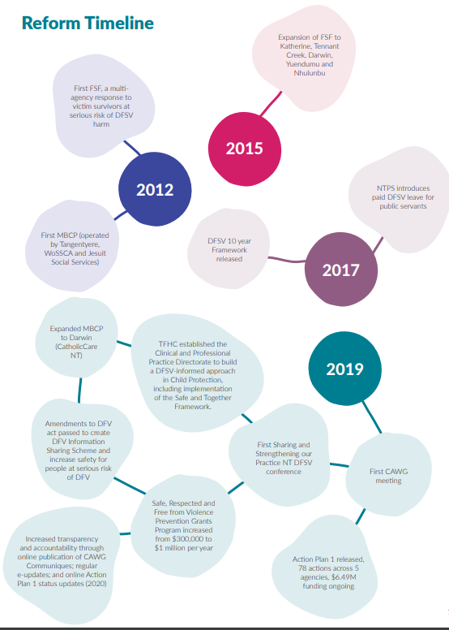
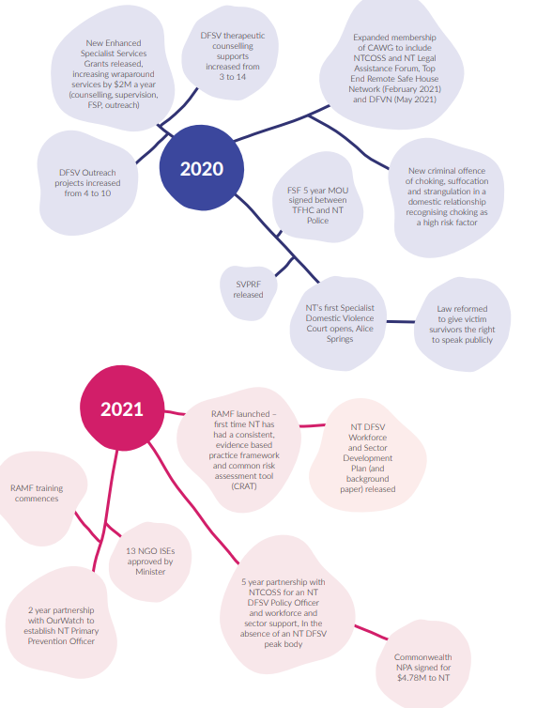

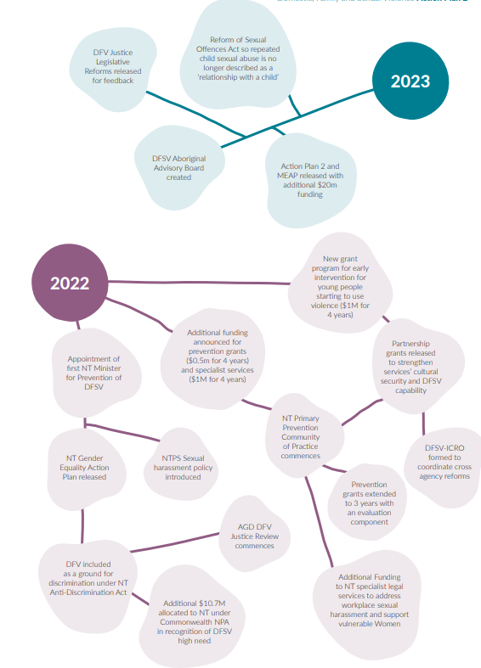

Front cover artwork:
“Tjulpu Wiltja Tjuta” (bird’s nests), by Yankunytjatjara and Pitjantjatjara artists Iluwanti Ken and Mary Katajuku Pan.
“This is the story of the Patupiri (swallow) who is clever, knowledgeable and skilful. Patupiri builds a safe, strong nest to protect its family against the rain and predators. It uses sticks and branches to build a strong and secure shelter, finding and gathering grass, feathers and mud to make the nest warm and comfortable so that its babies can grow and develop.”
Tjala Arts The swallows’ nests expresses our vision for a future where women and children are safe, and families are supported to thrive. This work, like the basket making art across central Australia and Arnhem Land represents what it takes to make this happen. Innovation, cleverness, local knowledge and relationships, ways of sharing information and skills, helping and working together. These are essential if we are to reduce violence.

