Chair 2
Chris Blackham Davison 2
Vice Chair 3
Lily Reid 3
Member 4
Jameson Casson 4
Member 5
Christine Cumaiyi 5
Member 6
Christos Timotheou 6
Member 7
Kate Ranford 7
Member 8
Marlene Karkadoo 8
Member 9
Gwilym Conran 9
Member 10
Michelle Mayes 10
Member 11
Henbury School 11
Member 12
Acacia Hill School 12

Chair

Chris Blackham Davison
Chris has lived in the Northern Territory (NT) for many years and has experience with a number of NT Government systems including health, justice and education. As a participant of the National Disability Insurance Scheme (NDIS), he understands the application process and what is required as a participant.
Chris is a special education teacher and has been teaching in the NT since 2001. He is actively involved in his local community participating in and volunteering with a variety of local organisations including Variety NT, the Cancer Council, and the Starlight Foundation. Chris undertakes public speaking engagements to talk about his experience with a hearing impairment, hearing dogs and organ donation.
Chris has identified a number of issues he believes are important for Territorians living with disability, including greater inclusion for people in their local community, improving supports for people with disability and increasing support to resolve difficulties people may have with the NDIS. “I want to help make the NT a better place for people with a disability”.

Vice Chair

Lily Reid
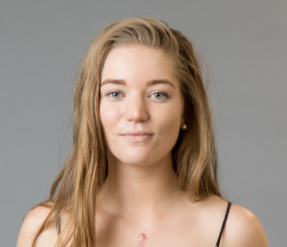
Lily is a young Territorian with a disability living in the rural area. She works as a Youth Development Coach in the Career Launchpad program with YouthWorX NT, which aims to assist young people with disabilities to form pathways out of school into sustainable employment.
Lily is a very active community member, advocate and volunteer, teaches dance to young children at a local dance studio, has been an ambassador for HeartKids SA/NT and has been a member on the Youth Round Table.
Lily would like the NT Disability Advisory Committee (DAC) to consider issues like accessible transport, access to quality and active services, universal accommodation and the Australia’s Disability Strategy beyond 2020. Also, mental health services to cater for people with disability and quality training for educators.

Member

Jameson Casson
Jameson is a Warumungu speaker and resides in the remote town of Tennant Creek. He has a keen interest in helping other people and is a popular and active member in his community. Jameson is well known in his community as a musician and performer. His performance credits include the Desert Harmony Festival and performances with the Opera Australia Chamber Orchestra and the local women’s gospel choir. In 2014, he was awarded the NT Young Australian of the Year for his work raising funds for new sporting equipment for youth in his community. More recently, he won the Arnold “Puggy” Hunter Award for his volunteering efforts at the Stronger Futures Alice 3on3, which helped promote youth leadership and the importance of getting a good education.
Jameson currently works part time in a sports and recreation program where he provides leadership to children who look up to and respect him. He enjoys watching cricket and AFL and has an interest in player statistics. Jameson has lived experience of disability which will help him to make an important contribution to the DAC.

Member

Christine Cumaiyi
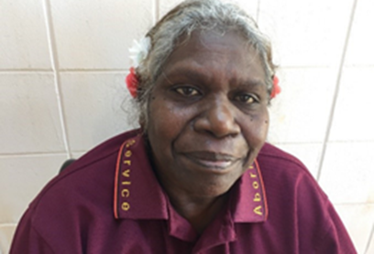
Christine is from the Wakal-Bangkun tribe and Kubyirr Country, a member of her community in Wadeye and one of the NT’s longest serving interpreters in the Murrinh-patha language. Christine has worked as an interpreter for the NT Aboriginal Interpreter Service (AIS) for over 23 years and as part of this role has developed a strong understanding of health, justice and education systems and the interaction of these services with Aboriginal people.
Christine was raised in Wadeye and has been unable to walk since she was born, she uses a wheelchair on a permanent basis and is now an NDIS participant. She has the lived experience of managing her disability whilst having a career and supporting her community.
In 1999, as part of the World Health Organisation, Community Based Rehabilitation Program, Christine visited Nepal, Bangladesh, England, and First Nations people in Canada as part of a study on how to support equal opportunities and improve social inclusion for people with disability. This experience inspires Christine in her membership on the DAC.
Christine’s vision is for a better way for people with disability to live where they can be included in the life of their community and where all people from all backgrounds, can take part in those things which are important for their culture and wellbeing. She is a strong advocate for people reaching their goals while living with a disability.

Member

Christos Timotheou

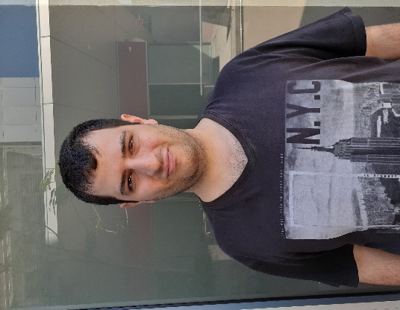

Christos lives in Darwin and is part of Darwin’s strong Greek community, he is a student with Project21 Post School Learning Centre and is learning about committees, human rights and issues for young people. Christos volunteers with Down Syndrome Association NT and was one of six students who attended the Having a Say national conference in 2020. This will the first time the NT attended this national conference and it was an important opportunity to practice leadership skills and meet like-minded people from around the nation.

Christos wants to be on the DAC to discuss issues like safe transport, more jobs and how people with a disability can have their voices heard. He would like to achieve people with a disability having a bright and safe future ahead. Christos provides important representation for NT youth with disability, as an NDIS participant and one of the younger members of the DAC.

Member

Kate Ranford
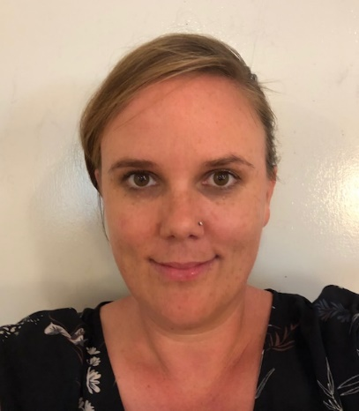
Kate and her family are fortunate to live and work in Nhulunbuy, in the pristine and remote East Arnhem Land. Here Kate is the carer to her ten-year-old son, and self manages his NDIS plan. She is well versed and experienced with the complexities of accessing and utilizing the NDIS service system. Kate’s background includes time worked in the health sector as a registered nurse, and in the justice system as a police officer. Her time in both professions has provided a great foundation for working in remote localities, and in culturally diverse settings. In her spare time, Kate and her family enjoy fishing, 4x4 adventures, visits to local waterholes and communities.
Kate’s reasoning for her membership on the DAC is to advocate for those living in remote Australia with a disability. She believes that all persons irrespective of race, religion or cultural background should have equal opportunities to access services and supports to improve their quality of life. Kate is passionate, tenacious, and committed to ensuring that services are accessible and financially viable for all people in remote localities.

Member

Marlene Karkadoo
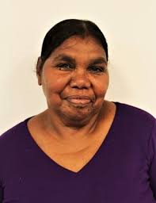
Marlene is the mother and legal guardian of a person with disability. She is a keen advocate for people with disability to be able to access all areas of our community and would like to see people in the community trained in working with people with disability so that people with disability can return home to community and be cared for.
Marlene works in the arts industry as the Event Coordinator for Artback NT, coordinating the annual Cultural Festival in Borroloola. She also assists in the management of the Waralungku Art Centre, a part of the Marbunji Aboriginal Resource Centre. She has a background in media, is a local Councillor for the South West Gulf Ward and has held many other community roles, including being a committee member of the Sea Rangers and Chairperson of the Borroloola School Council. Marlene is an accomplished public speaker, and does ‘Welcome to Country’ events in Borroloola.
She has participated in the Economic Development Forum, completed the NT Government First Circles Leadership Program, as well as various other management training courses such as Community Management and Development through Curtin University.

Member

Gwilym Conran
Gwilym is a carer of his son, a young child with a rare genetic condition and the National Secretary for the Cornelia de Langer Association (Australasia).
Gwilym self manages his sons NDIS plan and accesses extensive services across NT health services. He is an extremely strong advocate for getting the best from the services on offer to improve the quality of life for his son. He is a strong leader of people and an influential advocate and would love the opportunity through the DAC to share his experiences and help others achieve some of the same outcomes he has achieved for his son.
Gwilym considers awareness as a key issue and would like to explore the role of information and access to services. He believes it’s critically important that all those who require services are able to access them without hindrance. He believes it is important that the phrase ‘disability’ doesn’t become a tag and, although it is required to access services, that it isn’t a limiting factor in the individual’s ability to excel at whatever it is they choose to pursue in both their personal and professional life.

Member

Michelle Mayes
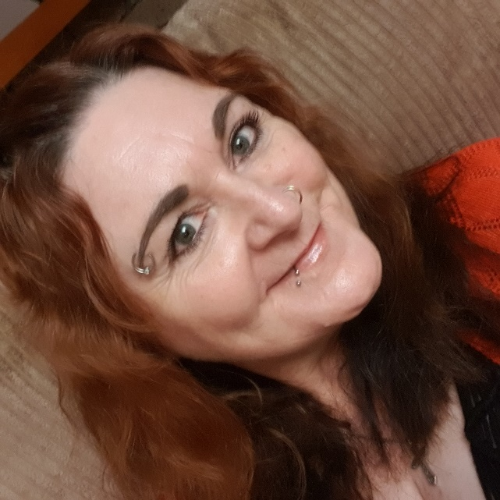
Michelle has lived in Alice Springs for six years and has worked in the welfare and social services sector for nearly 30 years. Her career has involved working with people and particularly youth, who have experienced trauma, mental health conditions and substance use, child protection and youth justice system. Michelle has a strong understanding of the role disability can play for people within these service systems. Michelle also coordinated the Central Australia Fetal Alcohol Spectrum Disorders (CAFASD) Network for three years which was made up of community service organisations and carer representatives and can speak confidently on the impacts of FASD.
Michelle provides important representation on the DAC for people who have a mental health condition as their primary disability. Michelle would like to see:
- greater access to services which are consistent in their approach to care and support and are affordable;
- an increased focus on consumer participation in decision making and consideration of peoples lived experience as an important component of evidence based practice;
- greater focus by employers to make reasonable adjustments in the workplace in order that people with disability can achieve successful and rewarding careers; and
- greater awareness of the impact of stigma on people’s lives and their ability to live their lives to their full potential.
As a DAC member, Michelle said “I would like to be involved in a process that endeavours to consider system change on behalf of the best interests of the persons who use those systems. I think it is also important for Government to hear the lived experiences of people and how current systems have a practical impact on people’s lives.”.

Member

Henbury School
Henbury Schools provides specialised programs for students with high support needs in the Darwin region. Henbury students vote to appoint 12 Learning Commissioners to represent them at interschool meetings, school council and at the NT Learning Commission. Learning Commissioners will attend the DAC meetings and report back to fellow students, school council and at the NT Learning Commission.
Henbury School Student Membership on the DAC allows for a different student to attend each DAC meeting to share ideas from the Henbury School, the Henbury on Aralia Café and Op-shop work programs, and students outside school experiences. Students can contribute to discussions, vote on recommendations and feedback to other Henbury students on the outcomes of the DAC.

Member

Acacia Hill School

Acacia Hill School is a specialised school setting catering for students with intellectual impairment and multiple complex disabilities in Central Australia. Students are aged from three to 18 years and come from the Central Australian region. The school has over 90 students and consists of a ‘base’ school at Acacia Hill and satellite classes in mainstream schools which aim to support students to transition into mainstream settings.
Acacia Hill School Student Membership on the DAC allows for a student from Acacia Hills Student Leadership Group to attend each DAC meeting to share ideas from their school, outside school experiences, contribute to discussions, vote on recommendations and feedback to other Acacia students on the outcomes of the DAC.

