Territory Sports Academy
Officiating Development Grants 2021-2022
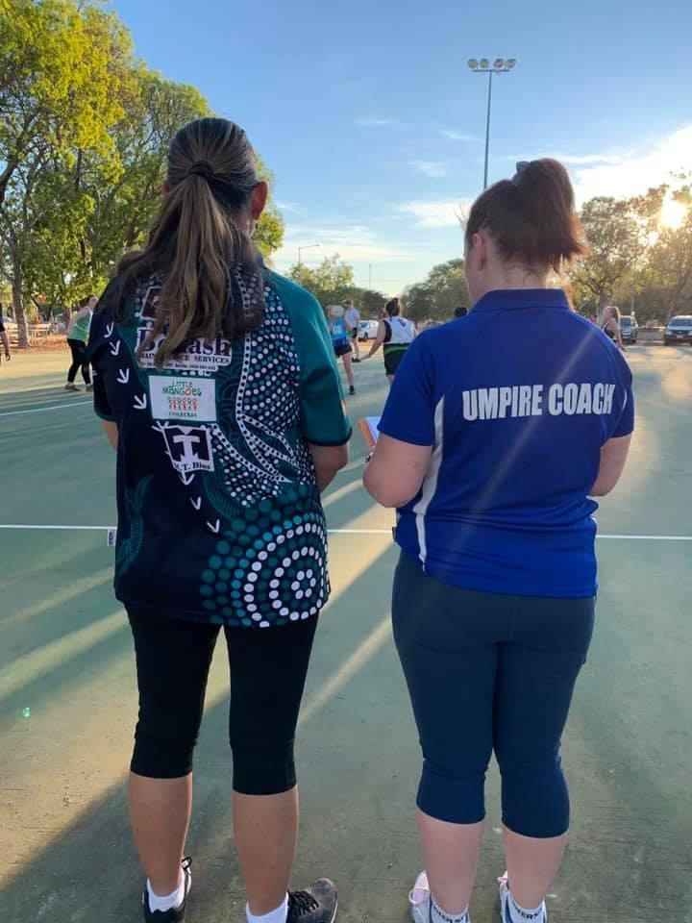
Document title | Territory Sports Academy Officiating Development Grants 2021-2022
Contact details | (08) 8922 6841 or TSA.WorkforceDevelopment@nt.gov.au
Approved by | Ian Ford/Brenton Toy
Date approved
Document review | Annually
TRM number | SR2021/0050-0001

Version | Date | Author | Changes made
1.0 | 15/07/21 | Graham Glassford | Standardised acquittal date (2)  Deleted clause of PSB’s not being allowed to apply for a similar category while having an unacquitted grant. (6.1 & 6.2)

Acronyms | Full form
NSO | National Sporting Organisation recognised by Sport Australia
NT | Northern Territory
NTG | Northern Territory Government
OD | Officiating Development grant
PSB | Peak Sporting Body recognised by the NTG
the Department | Department of Territory Families, Housing and Communities
TSA | Territory Sports Academy

Contents
1. Overview 4
2. Key dates 5
3. How to apply 5
4. Who can apply? 6
4.1. NT Peak Sporting Bodies 6
5. Who cannot apply? 6
6. Grant Categories 7
6.1. Officiating Coaches/Educators 7
6.1.1. What can be funded 7
6.1.2. Funding will not be considered for: 7
6.2. Accreditation Courses and Competitions 8
6.2.1. What can be funded 8
6.2.1.1. Accreditation Courses 8
6.2.1.2. Competitions 8
6.2.2. Funding will not be considered for: 8
6.3. Officiating Academies 9
6.3.1. Eligibility for Officiating Academy applications 9
6.3.2. Minimum program requirements 9
6.3.3. What can be funded 9
6.3.4. Funding will not be considered for: 9
7. Budget information required 10
8. Assessment 10
9. Notification and Feedback 10
10. Payment of funding 11
10.1. Goods and Services Tax (GST) 11
11. Buy Local 11
12. General information 11
13. Definitions 12
14. Contact information 12
Darwin 12
Katherine 12
Alice Springs 12

Overview
The Northern Territory (NT) Government supports the delivery of sport and active recreation services to the community through a suite of grant programs aimed at increasing the number of Territorians who participate in sport and active recreation, and in turn receive physical health, wellbeing, social and community benefits.
The greatest level of participation in sport and activity recreation in the Territory is in grassroots sport and it is our intention is to ensure NT Government investment provides for the greatest number of people possible, while also meeting the changing needs of the community.
The Territory Sports Academy (TSA) Officiating Development grant provides opportunities for Peak Sporting Bodies (PSB) to strengthen the capability and capacity of sport to assess, coach, mentor, and educate NT officials; increase the number of Territorians officiating at higher levels in sport; and improve the knowledge, skills and experience of accredited sport officials participating in the NT.
There are three funding categories, Development of Officiating Coaches/Educators, Accreditation Courses and Competitions and Officiating Academies. Two rounds of applications will be conducted in 2021-2022.
In each round PSBs can apply for a grant in either or all funding categories to a maximum of $4 000 in each (i.e. maximum $12 000).
The Officiating Development grant is focused on the last two stages of Grassroots in the sport and active recreation continuum:
Stage |  | Participant | Level of Participation
Progression of Skills | Explore | Infants and toddlers | Learn elementary skills such as crawling, standing and walking
 | Fundamental Movement | Preschool children | Develop basic skills such as running, throwing and jumping.
Grassroots Sport and Active Recreation | Learn | School children | Develop more refined skills, learn the rules of games and positive attitudes towards sport and active recreation.
 | Participate | Young people and adults in clubs and local games | Participate in organised sport, training and active recreation motivated by multiple factors such as enjoyment, performance and challenges.
 | Perform | Players in regional and national competitions | Identify and develop talent in sports.
 | Excel | Athletes in international competitions | Achieve excellence in one sport and compete at a world-class level.

The Officiating Development grant is a key strategy of the Workforce Development Plan to provide ongoing support and investment in the development and retention of officials in the NT.

Key dates
Round 1
Applications open online 21 October 2021
Closing date for applications 11:55pm, 18 November 2021
Assessment of applications November/December 2021
Agreements finalised and funds available January 2022
Funding period 1 January 2022 to 31 January 2023
Acquittal Date 28 February 2023

Round 2
Applications open online 16 March 2022
Closing date for applications 11:55pm, 13 April 2022
Assessment of applications April/May 2022
Agreements finalised and funds available June 2022
Funding period 1 June 2022 to 30 June 2023
Acquittal Date 31 July 2023

How to apply
Round 1 applications open on 21 October 2021.
Round 2 applications open on 16 March 2022.
All applications must be lodged online via Grants NT by visiting https://grantsnt.nt.gov.au/
It is highly recommended you contact the Department for assistance with your application prior to submitting. Phone (08) 8922 6841 or email TSA.WorkforceDevelopment@nt.gov.au
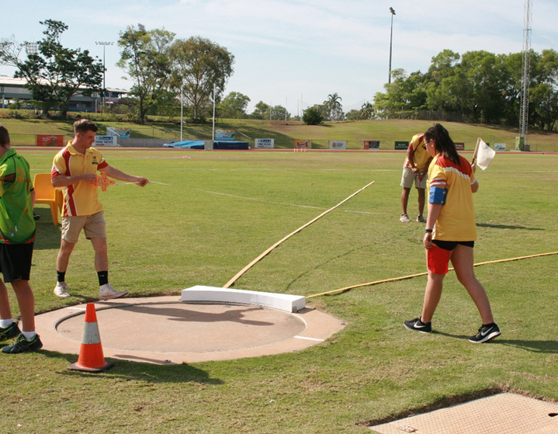

Who can apply?

NT Peak Sporting Bodies (PSB)
The PSB must:
- Be currently registered as an incorporated body with the NT Department of Industry, Tourism and Trade or hold another comparable legal status
- Operate as a not-for-profit organisation
- Be compliant with Licencing NT, or other relevant authority and
- Have current public liability insurance (minimum $10M).

Who cannot apply?
- Clubs, associations, regional councils, other organisations that do not meet the Department’s definition of a NT Peak Sporting Body
- Individuals
- Parents and citizens associations / parents and friends associations
- Local, State and federal government departments
- For-profit groups/commercial organisations
- Tertiary education institutions, school councils, student groups
- Organisations that are not based in the NT, or
- Organisations with outstanding government grant acquittals.

Grant Categories

Officiating Coaches/Educators
Funding is provided for officiating coaches/educators. Examples of the types of projects supported in each are listed below.
It is important that your application clearly provides the project details (the why), project activities (what and how the project is delivered) and the project measurables (specific outcomes on judging the success of the project) and that funding requested is directly aligned with these guidelines.

What can be funded
Costs associated with delivering:
- An officiating coaching accreditation/ training course including the travel of an intra-Territory or interstate presenter.

Costs associated in attending:
- An officiating coaching accreditation/ training course intra-Territory or interstate
- A sport specific officiating presenters, assessors, deliverers or mentor course conducted by your sport, or
- An intra-Territory or national competition to provide officiating coaching under supervision of a mentor/coach.

Funding will not be considered for:
- Activities or projects that have been approved under other NTG grant programs
- Activities or projects that are normally covered by the National Sporting Organisation (NSO)
- Applications that are not supported by a breakdown of costs
- Overheads involved with running an officiating coaching course including room hire, facility usage and cost of support materials such as printing and binding of manuals
- Hire car associated with attending an event
- Meals associated with attending an event
- Equipment or clothing (including uniform items), or
- Fees to maintain accreditation.

Accreditation Courses and Competitions
Funding is provided for accreditation courses/competitions. Examples of the types of projects supported in each are listed below.
It is important that your application clearly provides the project details (the why), project activities (what and how the project is delivered) and the project measurables (specific outcomes on judging the success of the project) and that funding requested is directly aligned with these guidelines.

What can be funded

Accreditation Courses
Costs associated with delivering:
- An intermediate or higher officiating accreditation course in the NT including the travel of an intra-Territory or interstate presenter.

Costs associated with attending:
- An intermediate or higher officiating accreditation course intra-Territory, interstate or overseas.

Competitions
Costs associated with officials officiating:
- At an event that meets the pre-requisites for a higher level accreditation or to gain a higher level accreditation
- At a national or international selection event (not fully funded by the PSB or NSO) that assists in being selected for a higher level competition
- At a state, national (including School Sport Australia) or international event (not fully funded by the PSB or NSO) that assists in maintaining accreditation, or
- At a state, national or international competition on the officiating pathways.

Funding will not be considered for:
- Activities or projects that have been approved under other NTG grant programs
- Activities or projects that are normally covered by the NSO
- Applications that are not supported by a breakdown of costs
- Applications to conduct beginner or introductory officiating accreditation courses (PSBs receive annual grant funding to support these courses)
- Upskilling officials ie. no formal accreditation course conducted
- Overheads including room hire, facility hire and cost of support materials such as printing
- Hire car , car parking, meals
- Equipment or clothing (including uniform items)
- Fees to maintain accreditation
- Participation in competitions that are not part of the NSOs or PSBs recognised officiating pathways
- Offsetting wages of employed staff, or
- Offsetting travel/accommodation costs of employed staff.

Officiating Academies
Funding is provided to a PSB as seed funding (first year only) to establish an Officiating Academy. The academy can be either inclusive or exclusive. Sports with existing officiating academy programs are ineligible.

Eligibility for Officiating Academy applications
- An officiating coaching structure
- An officiating operational plan that is also linked to the PSB Strategic Plan
- An officiating pathway relatable to the NT and where the academy fits into the NT pathway
- A detailed budget for the academy including any co-investment from the PSB or other organisations
- A plan for the sustainability of the academy after the first year of seed funding, and
- A completed project proposal template (which will be provided).

Minimum program requirements
- Be conducted over the duration of a season
- Engage all regions where the sport is conducted
- Engage officiating coaches/educators/mentors in the delivery of the academy, and
- All officials involved in the academy program must have minimum level of accreditation and have officiated for at least one season.

What can be funded
- Intra-Territory travel and accommodation of officials involved in the Academy
- Coaching honorariums (up to no more than 50% of funding applied for)
- Academy uniforms (up to no more than 25% of funding applied for)
- Performance consultants (e.g. nutrition, sports psychology etc.) that reside in the NT, and
- Venue hire.

Funding will not be considered for:
- Any interstate travel
- Offsetting wages of employed staff
- Offsetting travel/accommodation costs of employed staff
- Any application that does not meet the conditions as set out in 6.3.1 and 6.3.2
- Any costs associated with delivery of officiating accreditation courses, or
- Equipment purchases.

Budget information required
The following is a checklist of budget information and documents that are required for your application.
- Detailed income and expenditure.
- All quotes and estimations used for the budget.
- Detail as to whether the budget is calculated excluding or including GST.

Assessment
Total funding is limited and subject to annual variation by the NTG. As such, all applications will be assessed on relative merit against the assessment criteria below. It is not possible to approve all requests for assistance, therefore grant funding should not be deemed automatic or anticipated, regardless of history or previous funding.
The application’s activities requested for funding will be cross-checked with other Department grant funding applications for duplication.
High Priority for Funding
- Applications in the category of Officiating Coaches/Educators or Officiating Academies.
- Applications in the category of Officiating Academies.

Assessment criteria for Accreditation Courses & Competitions
Categories supported | Points value
Olympic/Paralympic Games, World Championships | 4
Regional/remote officials | 2
Advancing level of accreditation | 2
International competition | 2
Includes assisting with mentoring officials in the NT | 2
Maintaining accreditation level | 1
National competition | 1
Youth aged officials involved | 1
Competition – non accredited related | 1

Notification and Feedback
Applicants will be notified the result of their application by email.
Successful applications will receive a grant agreement which will outline the level of funding approved and the key performance indicators.
The PSB must agree to comply with the conditions outlined in the agreement, sign the agreement and return it to the Department within 30 days so the funds can be paid.
Feedback is available on request.

Payment of funding
Payments will be processed upon the receipt of the signed agreement and will be paid via electronic funds transfer (EFT) to the organisation’s nominated bank account.

Goods and Services Tax (GST)
If the organisation is GST registered, the actual total is subject to GST and the following will apply:
- The total will be ‘grossed up’ by 10 per cent
- All budgets submitted must indicate if the calculations are GST inclusive or exclusive. If budgets do not indicate
- It is the PSB’s responsibility to ensure that the GST component is remitted to the Australian Taxation Office
- A ‘Recipient Created Tax Invoice’ will be generated showing the ‘grossed up’ amount and forwarded to the organisation once the funds have been released
- If the organisation is not registered for GST, the organisation is not required to pay GST and will not receive a ‘grossing up’ provision, and
- The organisation must advise the Department of any changes to its ABN or GST registration status.

Buy Local
The NTG is committed to supporting local Territory businesses through its Buy Local Plan. Applicants must use labour, services, supplies and material available within the NT, except where it can be reasonably demonstrated that it is impractical for commercial, technical or other reasons. More information can be found by visiting the website www.buylocal.nt.gov.au

General information
- These guidelines supersede all terms and conditions in previous guidelines administered by the Department and form part of any agreement for funding provided under this program.
- Funds may not be used for any other purpose without a request for variation and prior written approval from the Department.
- Funds are not granted retrospectively i.e. to projects that have occurred or commenced prior to the application or notification of success.
- Recipients will be required to comply with all conditions of a NTG agreement which includes participation in audits of funding use.
- The NTG reserves the right to withdraw approval for funding at any time if there is a change in circumstances in the nature or financial viability of the project, individual or PSB.
- If a funding recipient does not meet all requirements in the agreement, monies paid may be recovered as a debt due.
- Unexpended funds of the approved amount will be required to be refunded.
- Recipients will be required to acknowledge the government assistance (information on how to do this will be detailed in the agreement).
- It is a condition of application that details of successful and unsuccessful applications, including the name of the organisation, amount, purpose, and any special approval conditions may be published or used by the NTG in any form and at any time.

Definitions
Accreditation
The NSO’s competency based training program is required to be completed by an official in order to be nationally recognised within the sport. There are flexible methods of delivery of the curriculum (e.g. in a face to face classroom setting, through mentor sessions, face to face practical learning, e-learning, or a mixture of methods). It has previously been called the National Officiating Accreditation Scheme (NOAS).
Introductory Accreditation
The NSO’s introductory level qualification in your sport’s officiating pathway. It may be known as Community, Beginner, or Level 1 accreditation.
Official
An official is a person who controls the running of a competition by applying the rules and laws of the sport. “Official” is the generic word. Other titles include referee, scorer, linesperson, umpire, judge, technical official, chair umpire, timekeeper, commissaire, tournament director or marshal. Sport officials also include coaches/educators of officials. Each type of official should have an NSO recognised training program. Not included are persons in roles related to sport/team/event administration/management, announcers or coaches of athletes.
Officiating coaches/educators
An officiating coach/educator is a person responsible for training officials by analysing their performances, instructing in relevant skills and assessing competencies as per the NSO’s accreditation framework/guidelines and by providing encouragement. Officiating coaches/educators can also be known as officiating assessors, developers, mentors, observers or instructors.

Contact information

Darwin
Territory Sports Academy
Level 1, Arafura Stadium, 40 Abala Road
Marrara NT 0812
Telephone: 08 8922 6841
Email: TSA.WorkforceDevelopment@nt.gov.au

Katherine
Ground Floor, Government Centre
First Street, Katherine NT 0850
Tel: 1800 045 678

Alice Springs
Ground Floor, Mwerre House
60 Hartley Street, Alice Springs NT 0870
Tel: 1800 045 678

